Christophe SAURY G20239056
Optical Illusions using phone input

For this wekinator project, I wanted to do an optical illusion that takes parameter input from the phone depending on the movement of the phone.
To do so I used dynamic time warping to record samples and train a model using accelerometer data coming from my phone.
The different states I have are according to the different outputs.
I have for output 1 a movement that makes the phone point up from when it’s just placed parallel to the ground (as if it’s placed on a table).
It corresponds to this position:

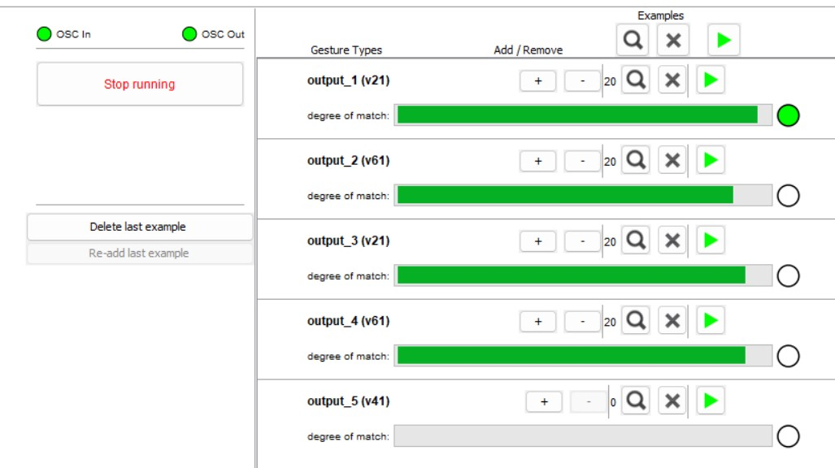
For output 2, I performed a movement where the phone rotates towards the right until it’s parallel to the ground faced down instead of faced up. (As if the phone is placed face down on a table)
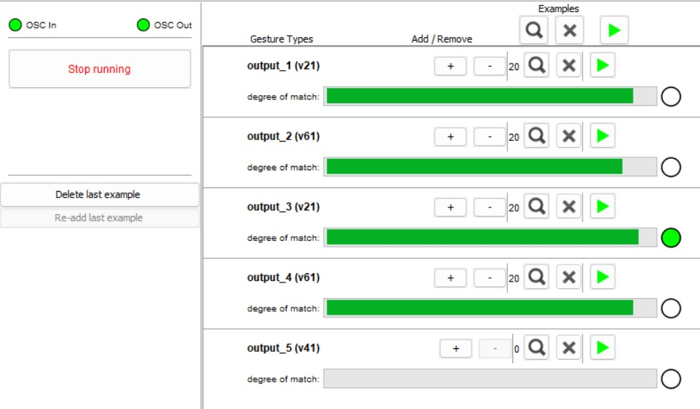
For output 3, I did the opposite movement of output 1, I move the phone in the opposite direction so that the phone points downwards.
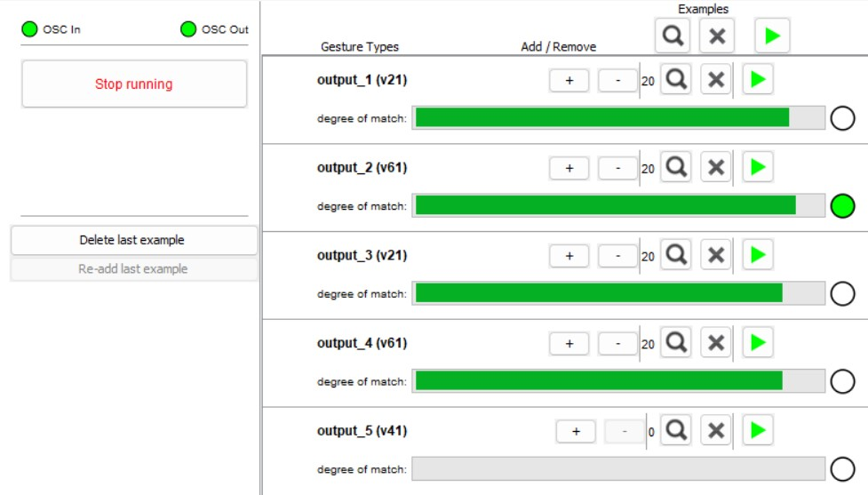
For output 4, I kept the phone face up on a table to record a default position and movement.

I then assigned different parameters to these outputs. The output 3 can be used to change the color of our sketch.
Output 2 can be used to reduce the scale of the sketch.
Output 1 can be used to change the angle of my ellipses that form the optical illusions.

The result of my code is the following: (I added a video to the zip)
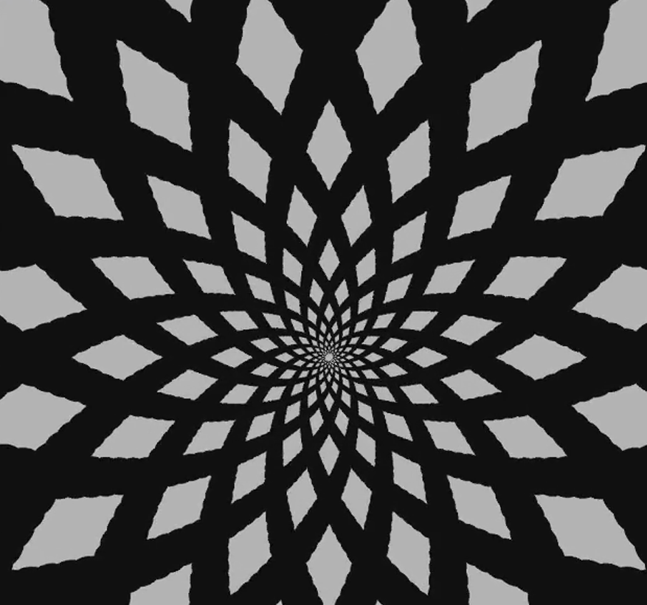
I can change the parameters using my phone to make the sketch different.
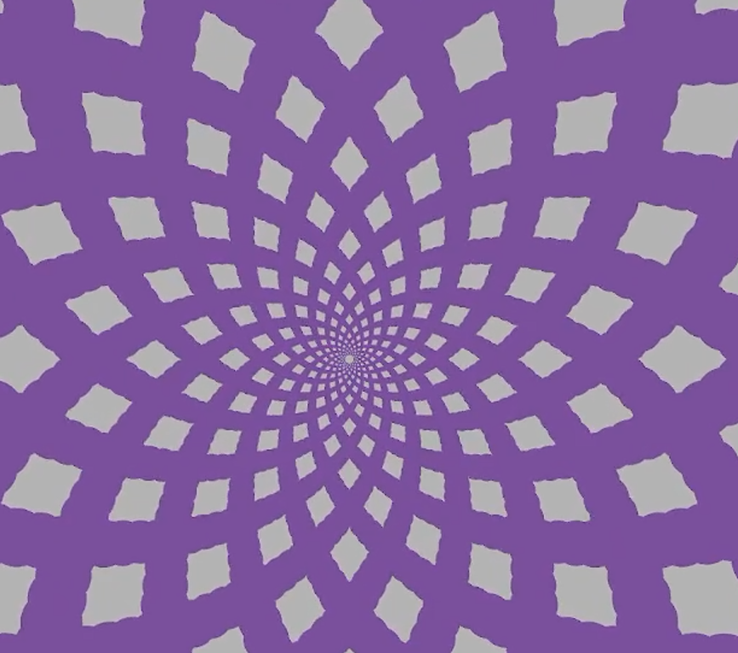
We changed the color in this one using output1.
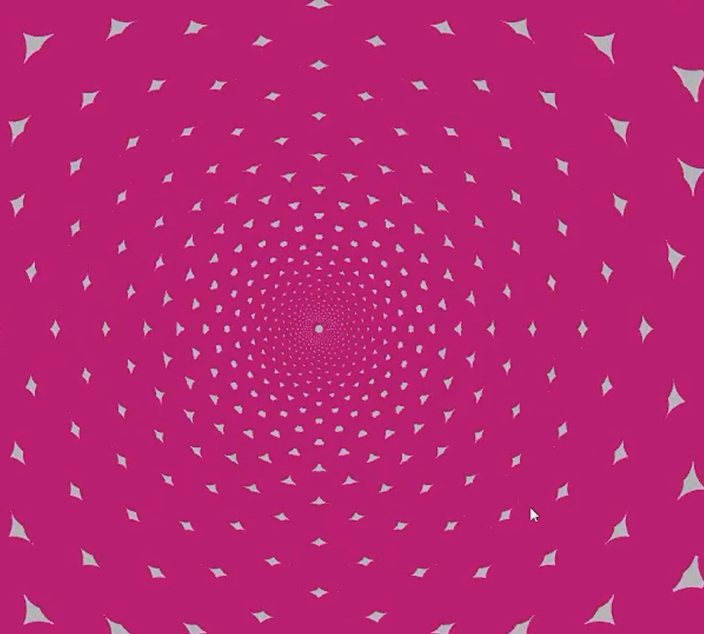
In this one, we changed both the color and the angle of the ellipses using output 1 and output 3.
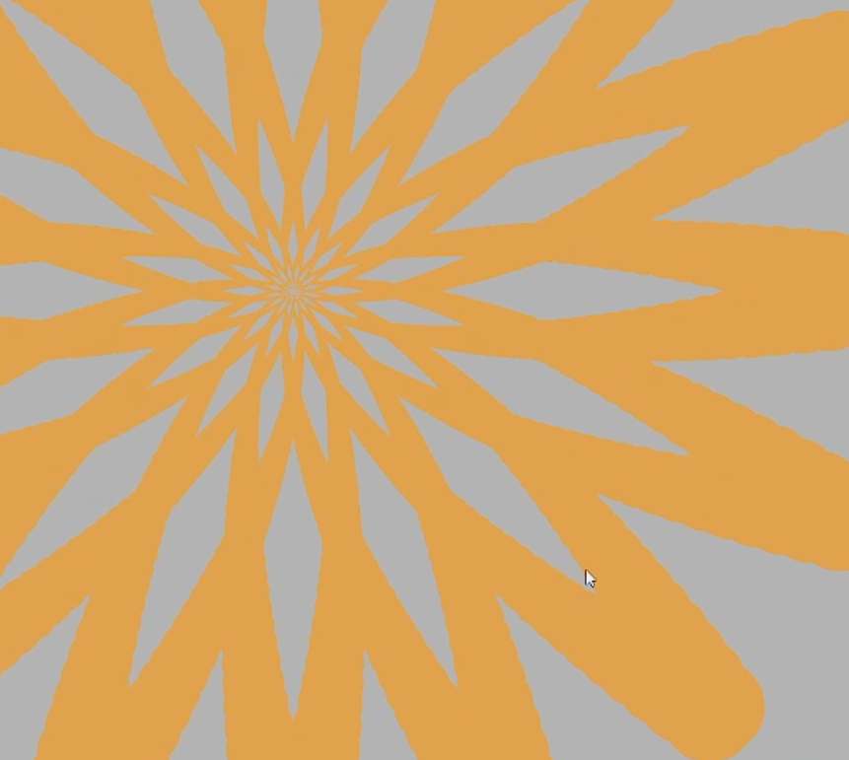
In this one, we changed the scale of the sketch using output 2.

Since my sketch is mostly about optical illusions, the results looks better while the code is running and has small changes occurring. I have attached a video to the zip.

